A plan of suitable size may be attached to this Report in preference to sketches on this page. Disposition and dimensions of superstructures, trunks, deckhouses, machinery casings; extent of bulwarks, guard rails and wood sheathing on exposed deck, to be inserted in the diagrams and table following; together with positions of hatchways, gangways, and other means for the crew; cargo ports, bow and stern doors, side scuttles, scuppers, air piper, companionways, and other items would affect the seaworthiness of the ship1.
Superstructure Deck
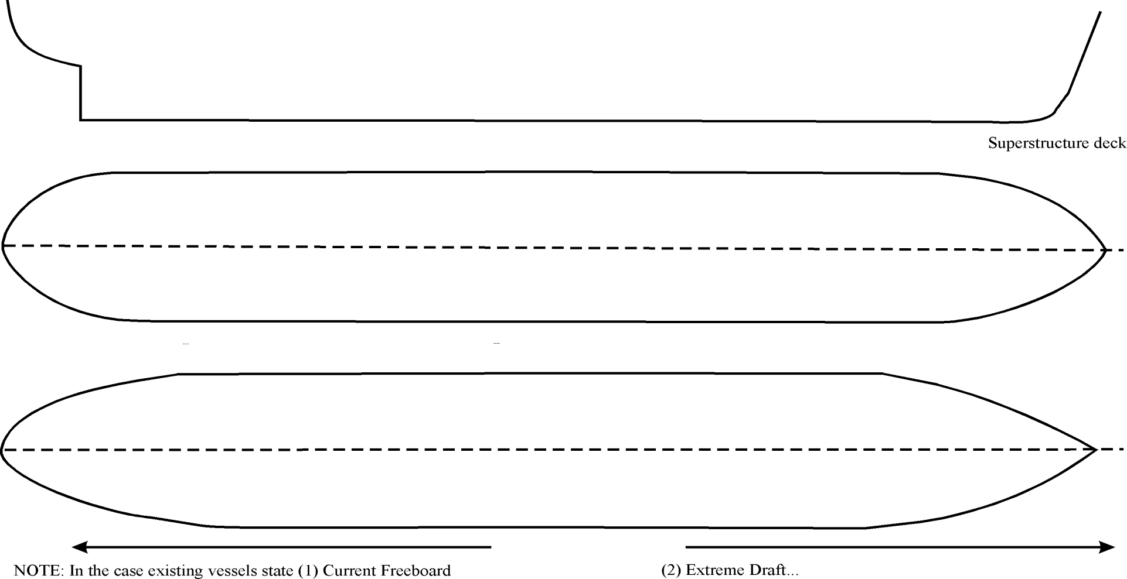
DOORWAYS IN SUPERSTRUCTURES, EXPOSED MACHINERY CASINGS AND DECKHOUSES PROTECTING OPENINGS IN FREEBOARD AND SUPERSTRUCTURE DECKS (Regs. 12, 17, & 18)
Freeboard deck

1 Please use the following notation for different items such as: for Air pipes; for Mushroom vents; for Deck Scuppers; for Goose neck vents; Doorways (superstructure & freeboard decks, exposed machinery casings, etc.);
Hatchways at position 1 & 2 fitted with gaskets and clamping devices; for bow & stern doors; for side scuttles; S for scuppers, I for inlets and D for discharges; for bulwarks, guard rails on expose deck; for other items; please specify.

GR CLASS – CLASSIFIED FOR STANDARD (GR CLASS)
E-mail: info@grclass.com Web: www.grclass.com

Form LL-02A Approved by: TM Page 1 of 1

